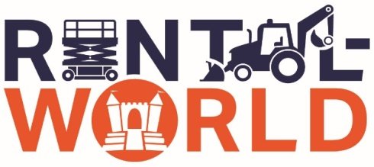

Certificate of Insurance Request

We will need a Certificate of Insurance to rent a lift from us.
The following requirements should be provided on the Certificate:
General Liability - $1,000,000/$2,000,000
Auto Liability - $1,000,000
Workers’ Compensation - $500,000
Named as additionally insured - F-Five LLC, DBA Rental World
1612 N. Broad Street
Lansdale, PA 19446

Additional Insured Applies on general liability required by written rental contact.

Please have your insurance carrier issue the requested Certificate of Insurance and email or present a copy to your contact at Rental World.

Sincerely,
Rental World Customer Service

