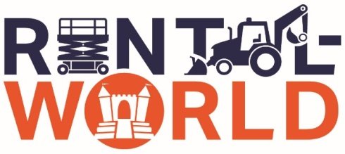

Certificate of Insurance Request

We will need a Certificate of Insurance to rent a lift from us.

**The following requirements should be provided on the Certificate:**

General Liability - $1,000,000/$2,000,000

Auto Liability - $1,000,000

Workers’ Compensation - $500,000

Named as additionally insured - F-Five LLC, DBA Rental World

1612 N. Broad Street

Lansdale, PA 19446

Leased and Rented Equipment coverage in the amount of $103,000.00

Please have your insurance carrier issue the requested Certificate of Insurance and email or present a copy to your contact at Rental World.

Sincerely,

Rental World Customer Service